Department of Physics – DRAFT
Guidelines for Promotion and Tenure
September 2022

  - Physics Department Ethos
The Physics department has a long history of innovative and high-quality teaching and mentoring, active and novel research, and service to the University and the broader physics/academic communities. Threaded throughout this history is a core belief that students learn physics best by doing physics and that the best physics faculty are consistently engaged in novel research and are active leaders/participants in the University and various other communities. With this in mind, physics faculty seek to articulate the mission of the University clear by modeling the connection between learning and life outside the classroom and service to communities.
The physics department recognizes that faculty should shape their own distinct identity and should have the ability to choose the path they take. A candidate should clearly articulate how this path connects to the values and objectives of the department and the University.
The department’s expectations focus on the three areas commonly classified as Teaching Effectiveness, Professional Achievement, and Service. These expectations are consistent with other physics departments at similar institutions (see Appendices). Department colleagues will provide context for the candidate’s path in each of the three areas through colleague appraisals. Of the three evaluation categories, teaching effectiveness and professional effectiveness clearly are the most important. Excellence in professional achievement and/or service will not make up for inadequate performance in the teaching area; advancement at Linfield will depend on excellent teaching. At the same time, performance in the other two areas must not be slighted. Accomplishment in these areas must be present for advancement, with professional achievement being more important than service

  - Teaching Effectiveness
Faculty should offer courses in a manner that encourages and challenges students to grow and excel. The organization and delivery of courses should be adapted for the needs of the course and to maximize student learning. Courses should be continually revised in a thoughtful manner, taking into consideration student and departmental feedback as well as evidence-based pedagogical techniques. The candidate’s promotion and tenure file should demonstrate this type of reflection and provide evidence that feedback from colleagues and students has been addressed.
Teaching effectiveness will be evaluated through a combination of student, colleague, and department chair appraisals. All tenured and tenure-track faculty members will collect student appraisals through formal course evaluations. The department has determined that certain courses (primarily lab courses) will not be evaluated in this way. This distinction is because students in experiential based courses struggle to reconcile the differences in class activities with the formal evaluation questions. Thus, courses such at PHYS 025 (Machine Shop), PHYS 210L and 211L, PHYS 385 and 386 may be excluded.
Colleague evaluations for the area of teaching effectiveness will be made primarily from discussions with the candidate, from classroom observations, and student evaluations. Untenured faculty are observed annually by the department chair and at least once prior to promotion by every tenured member of the department. Associate professors are observed by every tenured member of the department prior to promotion to full professor.

The University states the following evidence for teaching effectiveness:
- Knowledge of and enthusiasm for the subject matter
- Attention to the organization of courses as it relates to the level and preparation of the students
- Organization and effective use of class time
- High expectations for each student
- Respect for student’ viewpoints
- Use of effective and fair grading methods
- What students take from their course
- Availability for consultation with students
- Consistent and effective attention to the needs of advisees
In addition to these, the Physics Department values evidence of continued pedagogical development. Examples of how these might be fulfilled include:
- Continued growth in teaching style and approach, responding to the evolving needs of our students
- Evidence of continued course revision in response to student and colleague feedback
- Engagement with colleagues – either at Linfield or elsewhere – for the purposes of continuous pedagogical advancement
Advising and mentoring students is a central activity in the physics department and contributes positively to the experience of our students. Physics faculty are expected to regularly offer courses appropriate for advising (labeled ADV), to promote sufficient and close attention to advisees throughout their years in the department. Thoughtful mentoring of student teaching assistants encourages students to recognize the role between teaching and learning.
Lower Tier evidence of Teaching Effectiveness
- Contribution to courses of the Department, as needed
- Participation in/ contribution to laboratory sections of courses
- Documentation of advising activities, including general career counseling
Middle Tier Teaching Effectiveness
- Integration of laboratory sections of courses
- Development and implementation of new laboratory and/or lecture materials for existing courses
- Participation in pedagogical workshops and/or conferences (at Linfield or elsewhere)
- Involvement with the Society of Physics Students and Linfield’s chapter of ΣΠΣ
- Supervision of independent study courses
Higher Tier Teaching Effectiveness
- Reception of internal or external recognition of teaching excellence (i.e. teaching awards or other recognition)
- Significant contribution to the Physics and Applied Physics majors, such as implementing new requirements
- Development of new courses, including study abroad and INQS courses
- Significantly updating/revising courses within the major in order to keep material and pedagogical approaches relevant

Tenure/Promotion to Associate Professor: Faculty seeking tenure and status of associate professor should provide evidence of meeting the criteria described above. Through student evaluations, colleague evaluations, and a self-appraisal, a faculty member must demonstrate a thoughtful approach to their teaching and advising. Specific examples of improvement should be given as well as a development of a mature teaching philosophy. Although not all student evaluations must be positive, persistent challenges should be addressed in the narrative. We recognize, in particular, that some comments seen as ‘negative’ by students may, in fact, be part of an overall effective approach taken by the instructor. Colleagues and candidates for promotion and tenure will provide context for such comments in their appraisals.
They will fulfill the Lower Tier Teaching Effectiveness standards and show progress towards Middle Tier and Higher Tier Teaching Standards. Note that the lists of exemplars serve only as a representative list of ways in which a candidate may meet each tier. Items within a tier are not ranked, and the list is not a comprehensive checklist on which every item must be met.
Promotion to Full Professor: Faculty at this level should demonstrate special merit and continued growth in their teaching effectiveness. They will fulfill the Lower and Middle Tiers of Teaching Effectiveness and demonstrate progress toward fulfilling the Higher Tier.

  - Professional Achievement
The faculty in the Physics Department are expected to develop their unique professional identities through working in two broad fronts: 1) a record of individual professional scholarship arising from the candidate’s expertise in a scientific field, and 2) evidence that students are incorporated and benefiting from a colleague’s research program. Achievement must be demonstrated in both areas; outstanding achievement in one category will not take the place of an absence of activity in the other.
Evidence of professional scholarship primarily comes in the form of interacting with the scientific community. This interaction may take a variety of forms, of which publication in peer-reviewed journals, publication with well-established publishers of books, or successfully receiving external grant funding are considered the most highly regarded. Each of these interactions involves significant peer review by experts in the field and are the result of years of effort. Additionally, the department considers pedagogical research and publication in the field of Scholarship of Teaching and Learning (SoTL) within a candidate’s area, or within interdisciplinary areas to be of equal status with research in a candidate’s area of physics as these journals require the same peer-review as discipline specific publications. All peer-reviewed publications are valued as publications.
Other interactions with the scientific community could include presentations at conferences, publications in conference proceedings, presentations at disciplinary workshops, etc. Although in some cases there is a less formal peer review process prior to these activities, appropriate conferences may provide greater opportunity for experts in the field to comment directly to the work. As such, the department does not distinguish between conferences based on prior peer review but instead on the scope of audience one may reasonably be expected to reach. For instance, national conferences or conferences with narrow audiences/topics may be valued more highly than regional conferences such as the NWAPS or Murdock.
Work with multiple coauthors, including students, is common in physics, and can be regarded as highly as single-authored publications. Interdisciplinary research is also valued. In these cases, the faculty member should make clear their distinct, central contribution to the work. Presentations by Linfield students can also be considered as equivalent to a presentation by the faculty member, particularly at national meetings. In these cases, the faculty member should make clear how this research fits into the larger goals of the faculty’s work. It should be noted that each subfield in physics has its own culture for the order of authors, so it is incumbent on the candidate to clarify their role in the publication.
A typical line of investigation should be presented as it progresses. For example, presentation of initial results often occurs in smaller regional meetings, then as the project develops, at national meetings and ultimately results in publication in a peer-reviewed scientific journal.
Grant funding at research institutions typically comes from national funding agencies, such as the National Science Foundation (NSF). Grants from these agencies are peer-reviewed and are extremely competitive and are judged on their scientific merit and the contributions the proposed research will make to the field and training of future scientists. Funding rates for these grants are frequently less than 20%, and of that number even fewer are fully funded at the requested level. Securing funding from one of these agencies is strong endorsement for the research project and will likely lead to publication of the work in top peer-reviewed journals. Funding for faculty at liberal arts colleges may be available through private agencies and foundations, such as the Murdock Trust, the Petroleum Research Foundation, and the Dreyfus Foundation. Grants from these agencies are also peer-reviewed or reviewed at the foundation level and are highly competitive. It is not uncommon for grant proposals to receive favorable peer-review from selected experts in the appropriate field, but still not receive funding after review by the appropriate agency or foundation. The Department recognizes that the preparation of a proposal for external funding is a significant professional achievement, and therefore values even unfunded proposals as such, especially those that receive favorable comments from review panels and program directors. The weight (tier) is a function of the agencies assessment of the grant proposal, with funding of a grant being a higher-tier achievement.
Collaborative research with undergraduates is of particular importance to the ethos of the department, as it combines best practices for student learning with best practices for maintaining highly engaged and effective faculty. Mentoring students through collaboration aids students in understanding the complexity of doing physics and connecting their learning to activities outside the classroom. While we recognize that each line of scientific investigation is different and that involving undergraduates makes more sense at different stages of a project than others, the department expects that all faculty regularly engage students in their research. In particular, because every senior in either the Physics or Applied Physics majors is required to complete independent research and a thesis for graduation, faculty members must have research projects in which students can participate.
The exemplars below should not be considered exhaustive, nor should they be viewed as a checklist. Rather, the lists below are guides for candidates to frame their evidence for professional achievement.
Lower Tier evidence of Professional Scholarship
- Submission of a grant proposal (regardless of outcome)
- Peer-reviewed publications resulting from graduate and/or postdoctoral work
- Presentation of a poster at a regional meeting, such as the Murdock Conference that includes Linfield undergraduate co-authors and/or external collaborators
- Establishing a collaboration with colleagues, either internal or external to Linfield
- Seminar presentation of scholarship to a general or undergraduate audience
- Research that is not published but is referenced in a peer-reviewed journal
- Professional consultation that is both short-term and for no remuneration.
- Invitation to be a guest for established public facing science (e.g., podcast, blog, YouTube channel, OMSI After Dark, …)

Lower Tier evidence of Collaborative research

- Research with Linfield undergraduate students (SFCR)
- Mentoring senior thesis students on projects, outside of professional expertise
- Student presentations at regional conferences, or Linfield Symposium

Middle Tier evidence of Professional Achievement

- Submission of a grant proposal with subsequent positive feedback (although not yet funded)
- Invited seminar presentation of scholarship to a professional or graduate audience
- Presentation, either oral or as a poster, at a national, international, or specialized audience conference
- Professional consultation which is either long-term or remunerated
- Development, assessment, and dissemination of teaching materials for distribution to colleagues
- Experimental implementation of new pedagogical approaches, assessment, and dissemination of their outcomes associated with SoTL
- Create or regularly contribute to science-based podcast or other Public Facing Science media
- Peer-reviewed publications resulting from work at institutions prior to Linfield, in which the candidate was the principal investigator

Middle Tier evidence of Collaborative research
- Student Faculty Collaborative Research Grants
- Student presenting poster at National Conference
- Student presenting oral presentation at Murdock Conference
- Mentoring senior thesis within topic of professional expertise
Higher Tier evidence of Professional Achievement
- Submission and successful funding of a grant proposal (for research, SoTL, instrumentation, etc.)
- Publication of research done at Linfield or while working at Linfield in a peer-reviewed journal
- Authorship of curricular materials with subsequent peer-reviewed publication
- Delivery of an invited presentation at a national meeting
- Invited review of grant proposals for national and international foundations (NSF, NIH, etc.) which demonstrates expertise in a physics and/or educational discipline
- Authorship of a textbook, or chapter within a collection

Higher Tier evidence of Collaborative research
- Submission and successful funding of a grant including funding for student research
- Student receiving recognition at conference for outstanding poster or oral presentation
- Student co-author on research publication

Tenure/Promotion to Associate Professor: Faculty at this level should provide evidence of meeting the the majority of criteria from Lower Tier in both professional achievement and student collaborative research. In addition, the candidate should demonstrate ongoing Middle Tier (2-3 items each from Professional achievement and student research) and progress towards Higher Tier (no expectations of having met these). Typically, the program at this level may be narrowly focused and linked to the research done prior to joining the University faculty (either graduate or post-doctoral research). Evidence should be presented showing that future research agendas will be independent from his or her dissertation adviser, perhaps by finding new collaborations.
Promotion to Full Professor: Faculty at this level should provide evidence of meeting the criteria described above and that their program has expanded in a meaningful way. Typically, a program at this level may be broader or more substantial or significantly different from the faculty member’s original line of investigation or include a second line of investigation that may be pedagogical in nature. The rate and form of the professional achievement may vary over time, but evidence of greater visibility and continued engagement in this area is vital. There is an expectation of at least one original item from Higher Tier Professional Achievement, as well as continued growth in Lower and Middle Tiers.
Colleague evaluations for the area of professional achievement will be made primarily from discussions with the candidate, knowledge of their activities, and the context of conducting physics research at small undergraduate liberal arts colleges.
  - Service
Service activities are those that help further the mission of the University, contribute to one’s profession, or show involvement in the community. Physics faculty are expected to participate equitably in departmental and University-wide service. The activities include regular and effective participation on college-wide and university wide standing committees of the faculty, effective participation in departmental and divisional affairs, work with student activities and organizations, direct assistance with the external relations work of the University, service to the external community using professional knowledge and skills, service to a professional society/organization, and service to the online and continuing education division.
Physics departmental service includes activities such as advising the Society of Physics Students chapter, organizing teaching assistants, assessing, and revising curriculum, and participation in various other departmental projects. However, the faculty member should make it clear how these activities are distinct from professional achievement activities.
Examples of Service
Lower tier Service
- Effective participation in Departmental affairs – attending departmental meetings and events
- Demonstrated work with student activities and organizations, such as SPS
- Membership in professional organizations
Middle Tier Service
- Direct assistance with external relations of the University (recruiting students, speaking to alumni groups, administering or grading scholarship weekend exams)
- Leading activity for iFOCUS (pre-orientation camp for new Linfield students, in which the faculty member leads a research-based, hands-on experience) on behalf of the Physics department
- Participation on standing committees for the university or for the College of Arts and Sciences.
- Participation in ad-hoc committees, including search committees
- Editing articles on behalf of scientific journals
- Give public lectures to community groups or participate in community activities

Higher Tier Service
- Appointment as Department or Program chair
- Leadership involving a professional society/organization
- Chair or leadership position for university wide committee or standing committee for the College of Arts and Sciences
- Other high-level University related service, such as taskforce or administrative positions
Tenure/Promotion to Associate Professor: Candidates for promotion or tenure should demonstrate ongoing Lower Tier Service and some Middle Tier service. It should be noted, however, that the department strongly recommends that new faculty delay service commitments for the first few years in order to establish effective teaching practices and sustainable research programs.
Promotion to Full Professor: Candidates for promotion to Full professor must meet the criterion of special merit through demonstrating greater leadership. In addition to participation, there is an expectation that faculty at this level should take some leadership roles, whether in the department, the College of Arts and Sciences, the greater university or other physics/academic communities. The candidate should make it clear how their role constitutes leadership.
Colleague evaluations for the area of service will be made primarily from discussions with the candidate and knowledge of their activities.

Appendix A
Evidence of external comparison
The physics department promotion and tenure guidelines draw significantly from the Approved guidelines of three departments at Linfield University: the departments of Mathematics, Biology, and Chemistry. In addition, the guidelines of two peer institutions (Whitman College and University of Puget Sound) were also integrated into this work.
The physics department’s promotion and tenure guidelines affirm the centrality of student experience to the department’s activities, the agency of faculty members to chart their own path, and the active participation of physics faculty in various communities.
The importance of student experience is evidenced in the department ethos and woven into the teaching effectiveness and professional achievement sections:
Threaded throughout this history is a core belief that students learn physics best by doing physics and that the best physics faculty are consistently engaged in novel research...
Collaborative research with undergraduates is of particular importance to the ethos of the department, as it combines best practices for student learning with best practices for maintaining highly engaged and effective faculty.
The centrality of student experience is clearly stated in both Whitman’s and University of Puget Sound’s guidelines.
From page 1 of Whitman’s document (in Appendix B)
The Department of Physics expects each of its members be an excellent teacher, an available and understanding advisor and mentor to many students, and a productive scholar who is active in his or her discipline of inquiry.
From page 2 of University of Puget Sound’s document (in Appendix C)
Examples of activities that contribute to professional growth include: (1) original scientific research and publication. (2) scientific research that does not necessarily lead to publication but is presented to the scholarly community in some form. The Department recognizes that not every research project leads to a result publishable in a research journal. This is especially likely to be true of…projects designed to provide student research opportunities.
The importance of self-determination in professional achievement is evidenced in the department ethos section and is woven into the professional achievement section.
The physics department recognizes that faculty should shape their own distinct identity and should have the ability to choose the path they take. A candidate should clearly articulate how this path connects to the values and objectives of the department and the College.
While we recognize that each line of scientific investigation is different and that involving undergraduates makes more sense at different stages of a project than others, the department expects that all faculty regularly engage students in their research.
This sentiment is clearly stated in Whitman’s and inferred in University of Puget Sound’s guidelines.
From page 1 of Whitman’s document (in Appendix B)
Rather than encouraging a "one-size-fits-all" approach to scientific research, the Department recognizes that a diversity of approaches is valuable to the faculty, students, and more generally the College. Hence the Department encourages each faculty member to evaluate his or her personal strengths and interests to find the approach to scholarly engagement that works best given the available resources.

Appendix B
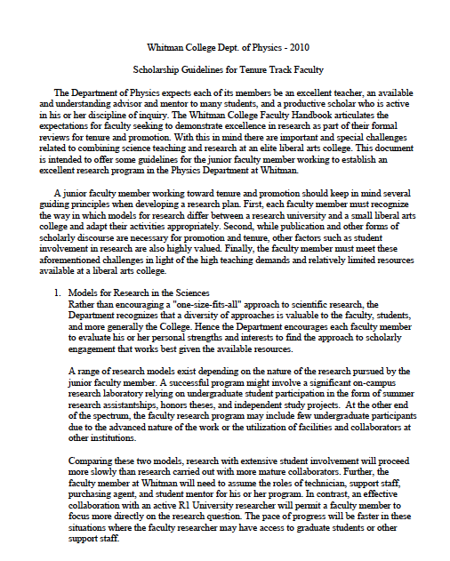

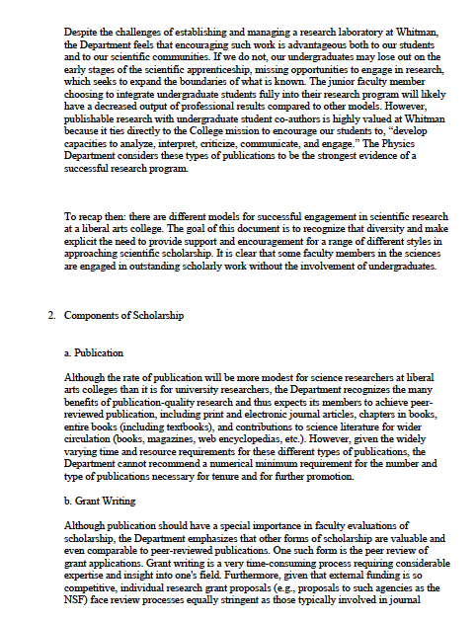

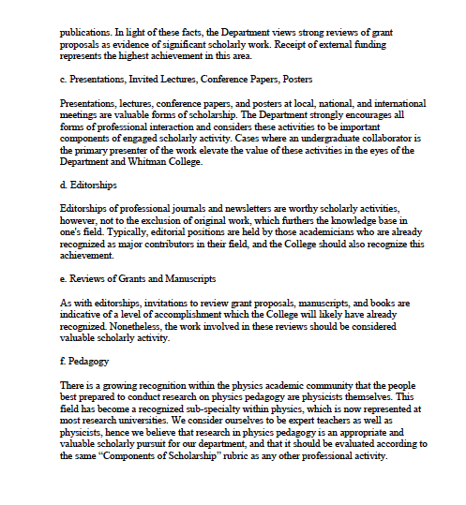

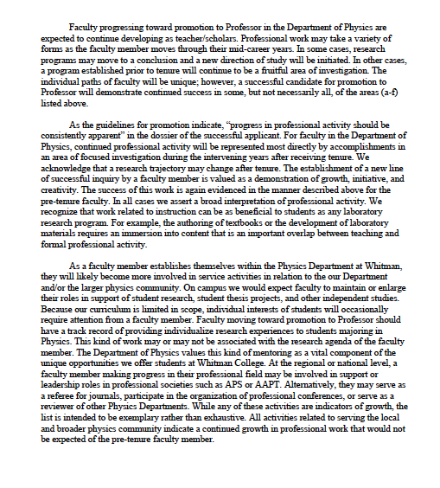

Appendix C
